**Website User Guide**

**Table of Contents**

1. **Accessing the Website**
   * Provides detailed instructions on how to access the website.
2. **Website Layout**
   * Explains the main sections of the site and its layout.
3. **Utilizing Website Features**
   * Guides users on how to effectively use various features of the website.
4. **Technical Demonstrations**
   * This section delves into the technical aspects of the website, including models, CSS, JavaScript, and feature implementation.

**1. Accessing the Website**

**1.1 Accessing the Link**

First, users need to understand how to access the website. Specific URLs or links are provided to ensure easy access.

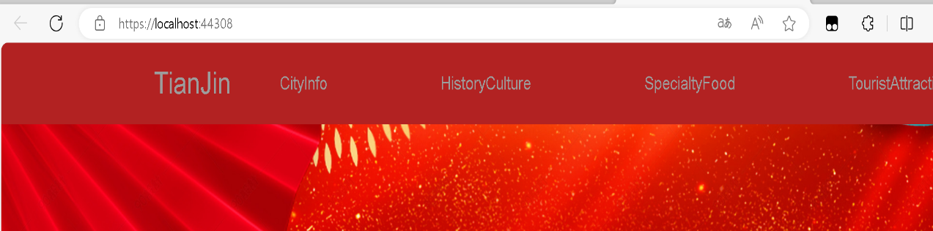

**2. Website Layout**

**2.1 Main Sections**

This section provides a detailed explanation of the main sections of the website, including the navigation bar, the main content area, and the footer. Users will gain an understanding of the overall structure of the website.

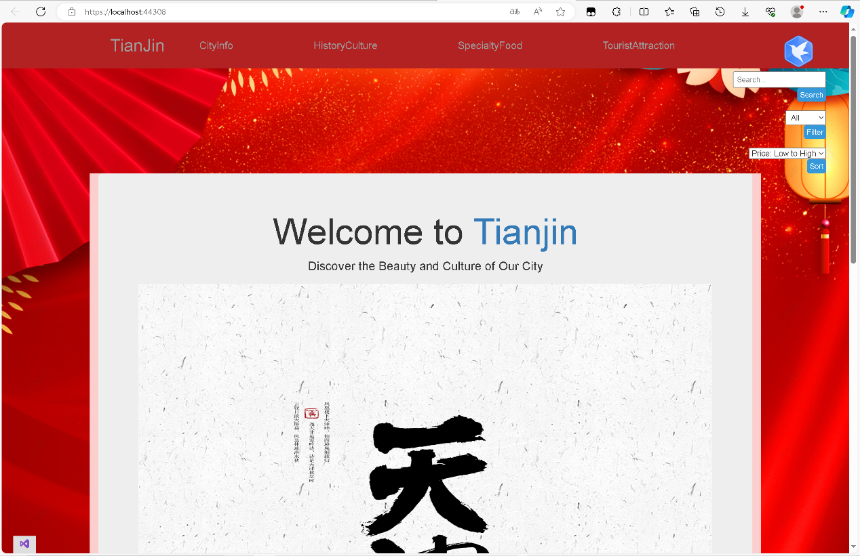

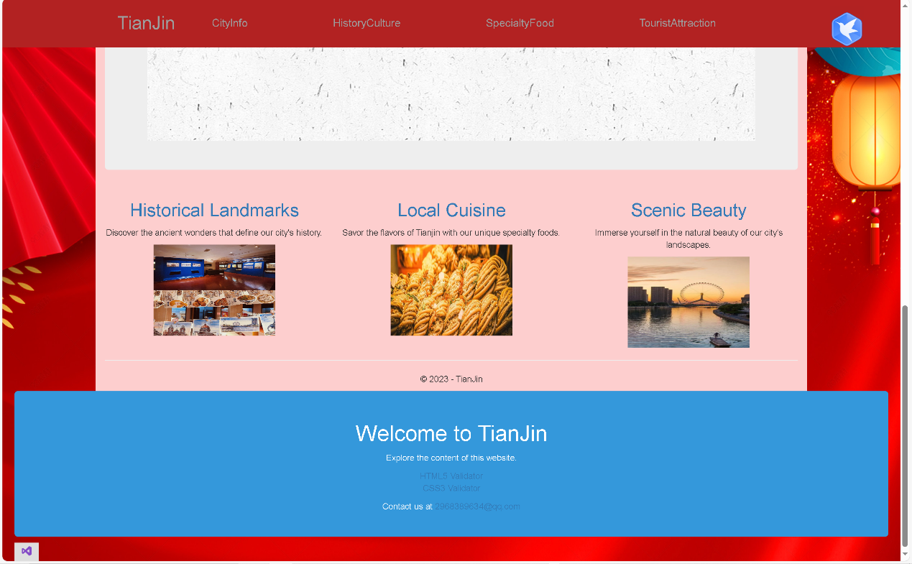

**3. Utilizing Website Features**

**3.1 Search Functionality**

Users will learn how to use the search functionality to quickly find the information they need. Sample search operations are provided.

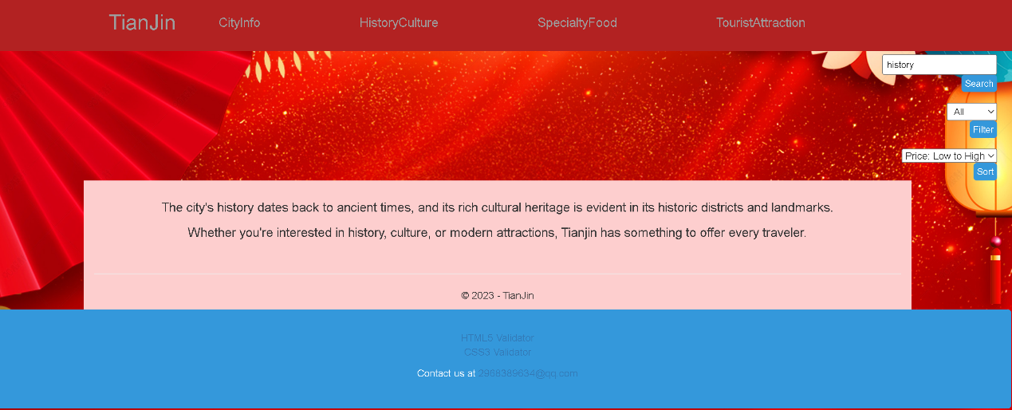**3.2 Filtering Functionality**

Explains how to use filters to narrow down content based on specific criteria. Users will understand how to filter data by category or other standards.

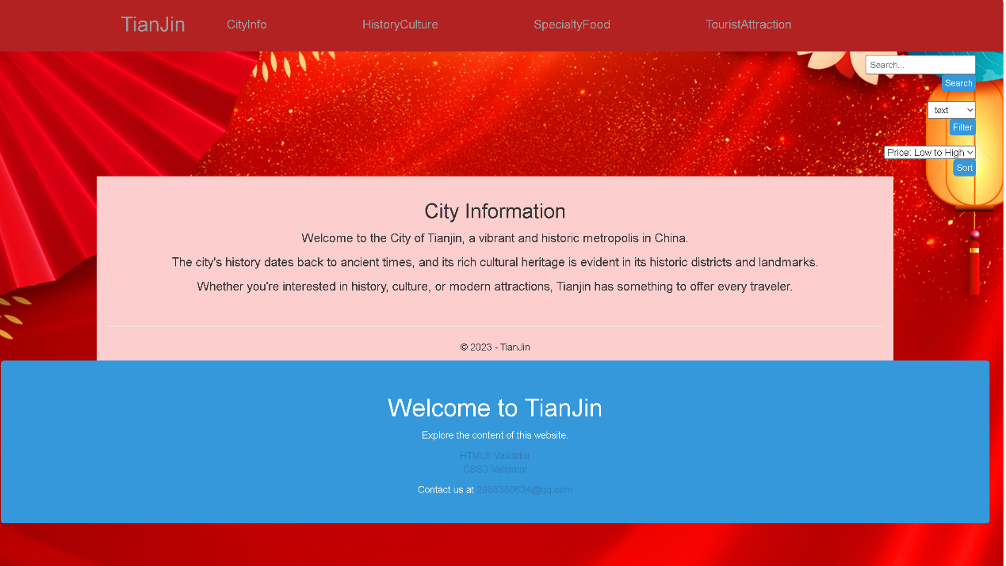**3.3 Sorting Functionality**

Detailed instructions are provided on how to use the sorting functionality. Users can choose to arrange content in ascending or descending order to meet their sorting needs.

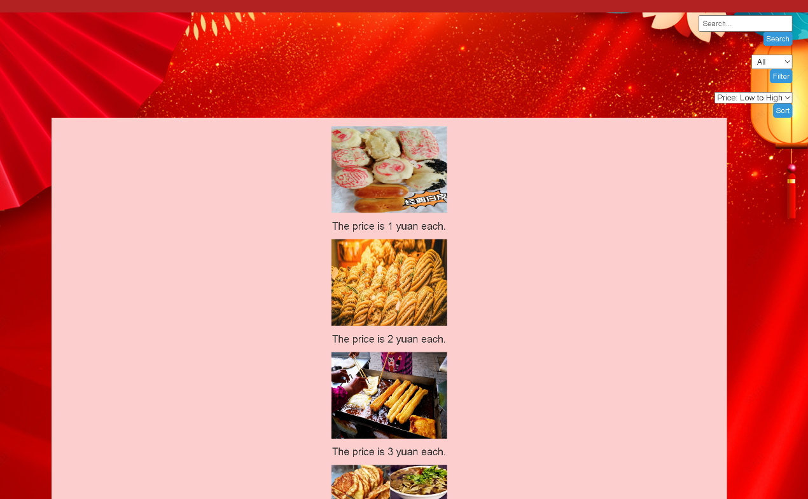**4. Technical Demonstrations**

This section delves into the technical aspects of the website to help users better understand how it works.

**4.1 Models**

Clear explanations are provided about the models required to create the website, ensuring users understand the data structure.

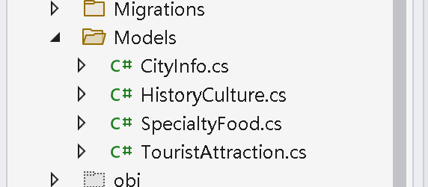

**4.2 CSS**

A detailed overview of the CSS used for styling the website is presented. Users will learn about design elements, colors, and fonts that constitute the visual appeal of the website.

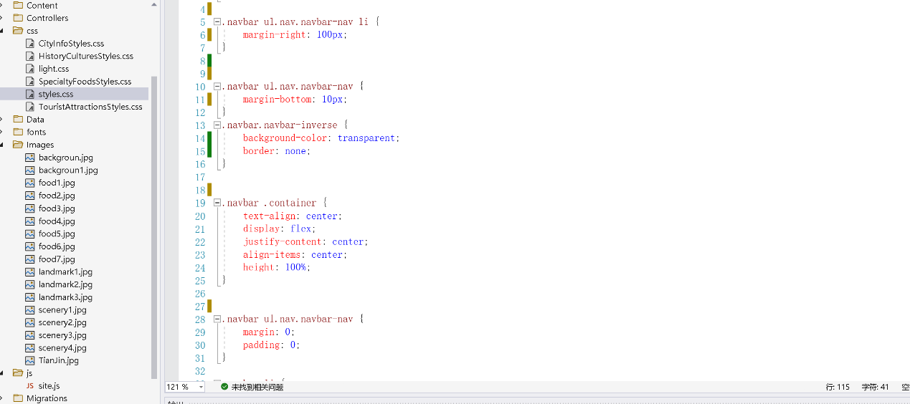**4.3 JavaScript**

An explanation of the JavaScript code used on the site is provided. Users will understand the interactive features and dynamic elements implemented on the website.

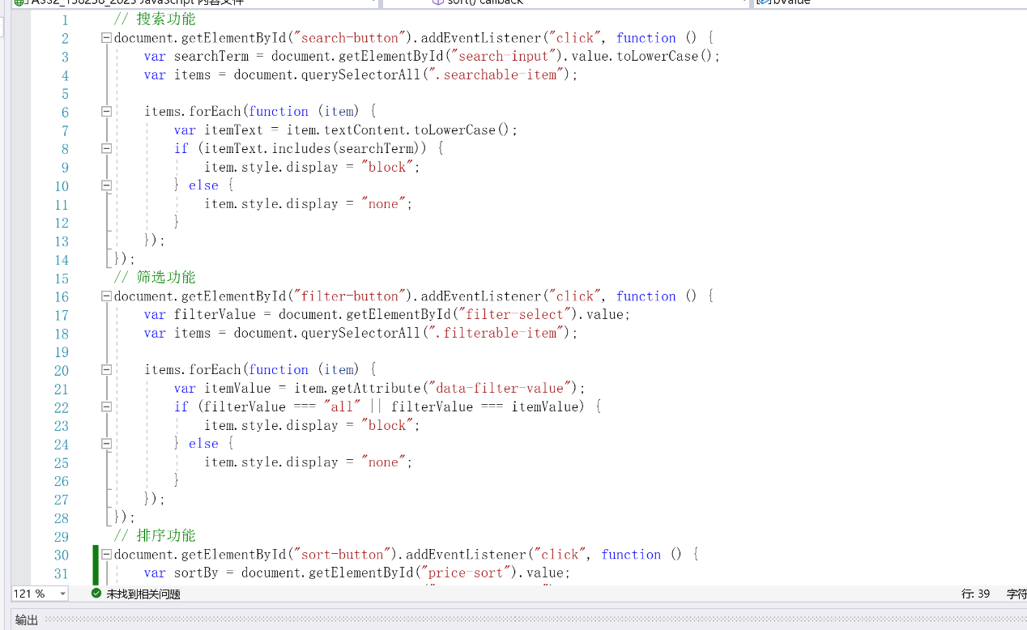**4.4 Feature Implementation**

A brief explanation of how key features like search and sorting functions were implem ented is given. Users will gain insights into the technical details.